events

Silverglade Festival

**Event Type:** Main Story

**Date:** 80 (10th day of winter)

**Description**: The town is celebrating the 50th anniversary of the town’s founding. The first mayor and founder of the town Kelris Silverglade. The towns people create booths to sell food, toys, and other wares. And festival games are held throughout the day. It is seen as disrespectful to do any work non-related to the festival as it shows that you do not see anything special about this day.

**Stalls:**

* Food: pies, candies, kebabs.
* Nestix: tops that don’t stop spinning, bouncy balls that bounce back to the users, some exotic fruits, and a single grimoire, a pendant that Torrins recognizes
* Games: snowball fights, sword fights, magic shows
* Fireworks

Vaelthor’s Incursion

**Event Type:** Main Story

**Date:** 100 (Last day of Winter)

**Description (Part one)**: Thalia gets her friends to come to her secret hideout that night as the sun is setting to celebrate the last day of winter. During this celebration she plans to reveal the magic that she has been preparing to impress all of her friends, she doesn’t know what it will do but she is confident it will be really exciting. She leads them into the forest through some thick brushes that open up into a wide clearing with some beautiful flowers. And in the center of the field that has been cleared out for and in there is a book laid open in the center inside a painted black symbol and on each of the symbols points a small flickering candle lay. The young elf child shouts “surprise” as she pricks her finger with a needle and drips a drop of blood onto the book. The symbols start to bleed into a crimson red and each of the lights go from a flickering orange flame to a straight blood red beam, and a red crackling energy connects each of the beams and the line starts to crack open as a long arm bursts from the crack. Then another arm the creature then rips the crack wider and steps out of the portal before the entire portal shudders a collapses. Out steps Vaelthor. He rips open a portal that magma hounds come walking out of.

**Symbol:**

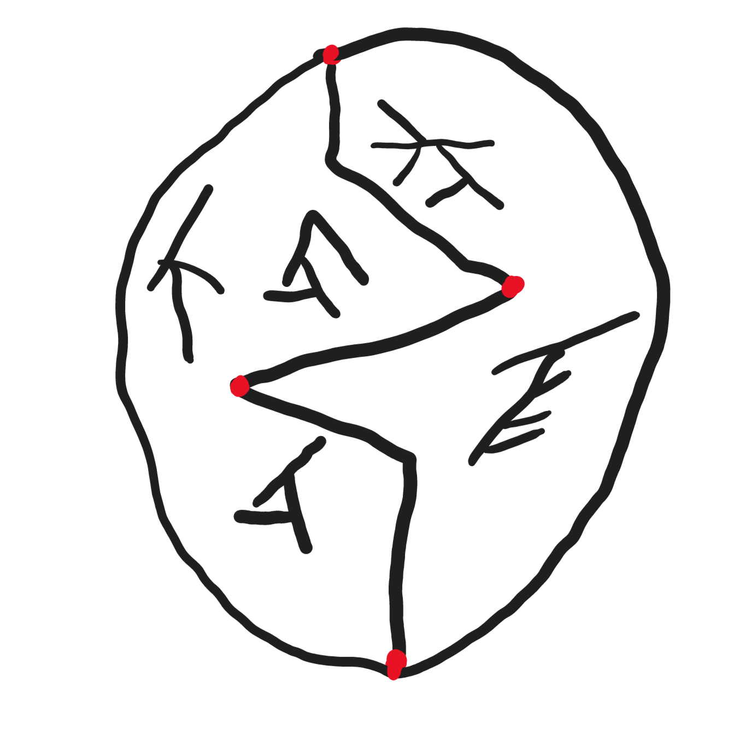

**Quotes:**

* “Wait for a second as I prepare the surprise” – Thalia
* “Ha! He actually chose a child for my host?!” – Vaelthor
* “Seems not only demons belong in Hell” – Vaelthor
* “While I can’t directly harm you, you need to prove your worth keeping around” – Vaelthor
* “Ha! Leaving you as you are, is a worse fate than anything I could do to you” – Vaelthor

**Misc:**

* Archie gets a sudden flash in his mind of the symbol crackling and gets a terrible feeling. That begins to fade quickly.

**Combat:**

* One extremely bloodied magma hound
* HP: 2
* AC: 10
* Abilities
  + Bite: +3hit/1d6+3dmg

**Description:** The town is aflame and the elven guard is quickly trying to organize to fight back, but civilians are dying in the streets. Most running though a few trying to fight, Brumgran is armed to the teeth with guns blowing up demons left and right, tossing extra weapons to anyone within sight. Ajani is battling the main demon he with his double-bladed axe and demon with its claws and teeth. Ajani drives his axe into the demon’s shoulder and it grips the axe in two hands but Ajani is stronger. The demon bursts two hands from its midsection and drives them right through Ajani’s torso. Ajani with his last breath tears the demons arm off before collapsing. The demon is forced to open a portal away but not before opening a small one to snatch Thalia.